Practice Questions
Vectors

- A displacement vector in the xy plane is 4.3 m long and directed at angle of 40° in Fig-1. Determine (a) the x component and (b) the y component of the vector.

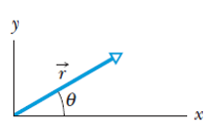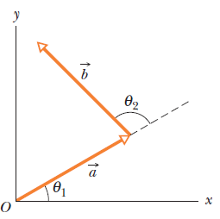
Fig-1 Fig-2
- The two vectors a and b in Fig-2 have equal magnitudes of 10m and the angles are θ1= 35$⁰$ and θ1= 102$⁰.$Find the (a) x and y components of their vector sum r (b) the magnitude of r and (c) the angle r makes with the positive direction of the x axis

- Find the area of the parallelogram determined by the vectors: 2i - 13j + 5k and 5i + 2j - 4 k. What is the area of triangle determined by 2 vectors A=3i+4j-k and B=-3i+7j-4k ?

- The x component of vector A is 25.0 m and the y component is 40.0 m. (a) What is the magnitude of A (b) What is the angle between the direction of and the positive direction of x?

- Find the angle between the vector A= 2i -3j+5k and the x, y,and z axes, respectively.

- Calculate the angle between “r” and the positive z-axis. (c) Find the angle between “a” and “b”. where a = 5i +4j -6k , b= -2i +2j+3k and c = 4i+3j+2k , r = a+b+c.

- Determine the value of “X” such that A = 4i + Xj + 2k and B = 4i - 8j - 2k are perpendicular.
- Vector a has magnitude 5.0 m and is directed east. Vector b has magnitude 4.0 m and is directed 35◦ west of north (Fig-3). What are
(i) the magnitude and
(ii) the direction of a + b?
What are
(iii) the magnitude and
(iv) the direction of b − a?
Draw a vector diagram for each combination.
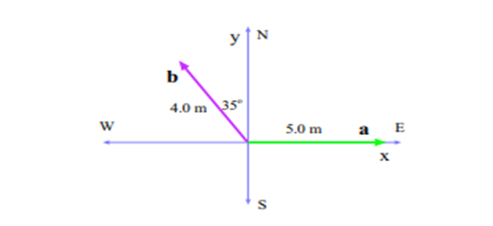Fig-3
- In the sum A + B = C, vector A has a magnitude of 12.0 m and is angled 40.0 ◦ counterclockwise from the +x direction, and vector C has magnitude of 15.0 m and is angled 20.0 ◦ counterclockwise from the −x direction. What are (a) the magnitude and (b) the angle (relative to +x) of B?
- Find the angle between A = −5i – 3j + 2k and B = −2j – 2k
- Prove that two vectors must have equal magnitudes if their sum is perpendicular to their difference.
- Someone claims to have found a vector A such that
Do you believe this claim? Explain by doing calculations.
- Two vectors are given by A = −3i + 4j and B = 2i + 3j. Find (a) A × B and (b) the angle between A and B.
- Vectors A and B lie in an xy– plane. A has a magnitude 8.00 and angle 130⁰: B has components B_{x}= -7.72 and B_{y}=-9.20 (a) What is 5A . B? What is 4A x 3B in unit vector notations. (b) What is the angle between the direction of vector A and vector (4A x 3B)? (c) What is A +3.00 k in unit vector notation and its magnitude?
- In Fig-4 , a vector with a magnitude of 17.0 m is directed at angle 56.0° counterclockwise from the +x axis. What are the components (a) a_{x} and (b) a_{y} of the vector? A second coordinate system is inclined by angle 18.0° with respect to the first. What are the components (c) a_{x} and (d) a_{y} in this primed coordinate system?
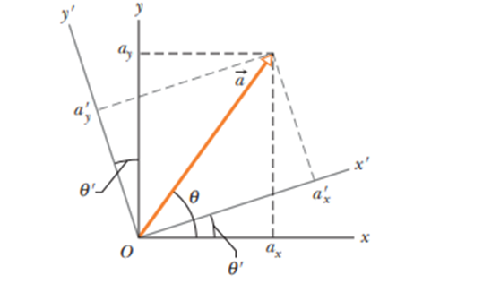Fig-4
- (a) In unit-vector notation, what is the sum a + b if a = (4.0 m)i + (3.0 m)j and b = ( -13.0 m)i + (7.0 m)j ? What are the (b) magnitude and (c) direction of a + b?
- A car is driven east for a distance of 50 km, then north for 30 km, and then in a direction 30° east of north for 25 km. Sketch the vector diagram and determine (a) the magnitude and (b) the angle of the car’s total displacement from its starting point
- The three vectors in Fig-5 have magnitudes a = 3.00 m, b = 4.00 m, and c = 10.0 m and angle θ = 30.0°. What are (a) the x component and (b) the y component of a ;(c)the x component and (d) the y component of b; and (e) the x component and (f) the y component of c? If c = pa + qb,what are the values of (g) p and (h) q?
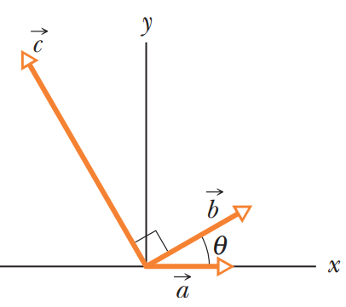

Fig-5

